# Midterm Project:

**Challenge 1 & 2**

## Name:

Rommel Hipos

**Date Submitted:**

## Challenge 1 - Simple static page server

* Use the folder challenge1.
* Add a "public" folder with some assets.
* Add a file with the name index.html. It should contain your **name** and **SAIT ID** in the contents.

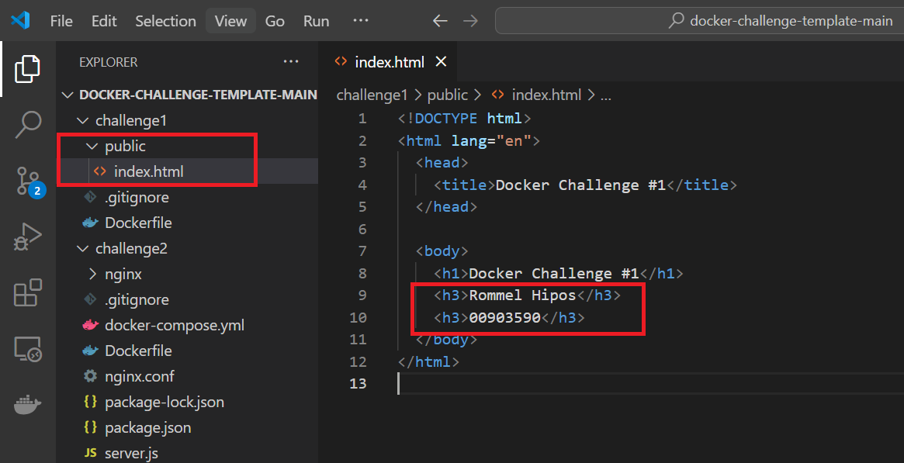

* Create a Dockerfile to use NGinx to serve pages existent in the public folder.
* Create the Docker image.
* Execute docker with the right parameters.

# References